Diffusion optics project -- process overview
This document walks through the full project, from tissue generation through wavefront correction to speckle statistics, for course submission. The accompanying submission/ folder contains a runnable copy of the final analysis (main.py + functions.py).

1. Goal and model
The project simulates multi-plane wavefront shaping (MWFS): a scattering tissue is approximated as M thin phase-only "aberration planes" separated by free-space propagation, and a corresponding set of conjugate-phase "correction planes" (as would be applied on an SLM) attempts to undo that aberration and refocus a point source. Each plane A_k is built from a generated 3D tissue volume as A_k = exp(i*angle(mask_f(:,:,k))) -- phase-only, unit amplitude. Propagation between planes uses the exact (non-paraxial) angular spectrum method, with evanescent spatial-frequency components dropped -- a physically necessary step (those components don't propagate in free space at all), not an approximation, for any propagation distance much larger than a wavelength.

2. Tissue generation and a real averaging bug
The 3D tissue (tissue_3d_generator.m) is a random field of spherical scatterers, downsampled from a fine (x_stp-spaced) z-grid into M coarse aberration planes by averaging. The original downsampling loop used a fixed tolerance (x_stp*0.75) to decide which fine layers belong to each coarse plane -- but that tolerance doesn't scale with the plane's intended thickness, so it only ever caught 1-2 fine layers, turning every "plane" into a thin ~0.1-0.2um slice instead of a genuine average over the full slab. Fixed by scaling the tolerance to the bin half-width (h_z_stp) with a small floating-point epsilon, matching the file's existing epsilon convention elsewhere. Verified directly in the generation log: each bin now catches exactly the intended number of fine layers (e.g. 75 of 75), tiling the full tissue depth with no gap or overlap.
A consequence worth noting: with the fix, for M=2 planes, plane A's averaging window is the tissue's entrance half (forward z in [0, Z/2]) and plane B's is the exit half ([Z/2, Z]) -- contiguous halves of the full depth, not arbitrary thin slices. This mattered directly for the capillary/RBC scenarios below: a capillary centered at the tissue's z-midpoint straddles exactly the boundary between the two planes' windows, so both planes get a meaningful share of it.

3. Sim step 1: ideal correction, static tissue
For a static (non-flowing) M=2 tissue, the correction planes are taken as the exact conjugate of the aberration planes (A~=conj(A), B~=conj(B)) -- "ideal" knowledge of the aberration. The full sequence is:
u_in -> propagate(eps) -> xA -> propagate(eps) -> xB -> xB~ -> propagate(-eps) -> xA~ -> propagate(-eps) -> u_out
u_in is a single point source at the center of the field. Because A~ and B~ exactly invert A and B, u_out refocuses back toward u_in -- limited only by the diffraction limit (the evanescent components discarded during propagation can never be recovered by any phase-only correction, since that loss is a non-invertible projection, not a phase error).
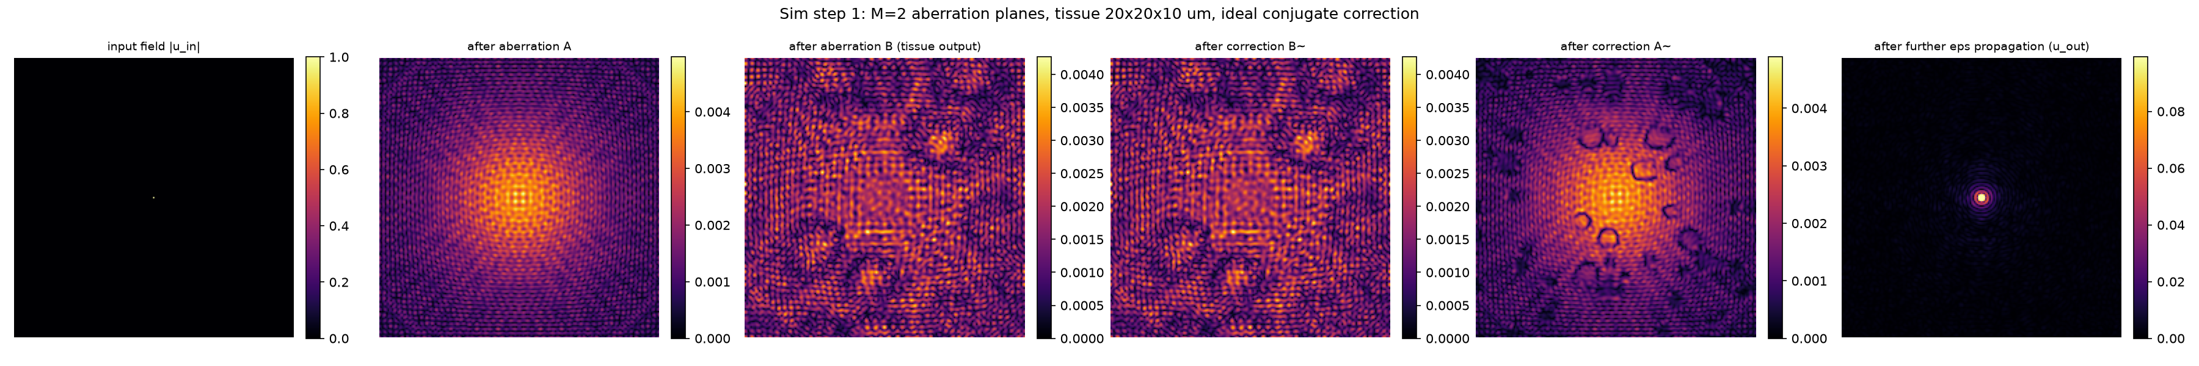
Figure: input field, field after each aberration plane, field after each correction plane, and the final refocused u_out (20x20x10um tissue, M=2).

4. Sim step 2: a flowing capillary with red blood cells
The static tissue is extended with a capillary (blood vessel) carrying red blood cells (RBCs), to model a tissue that changes over time. The capillary's axis runs along Y (lateral, not the z/propagation axis) -- its stated diameter is a circular cross-section in the X-Z plane, uniform across the tissue's full Y-extent. Diameter oscillates sinusoidally: diameter(t) = 7 - 3*cos(2*pi*t/8) um (4um contracted at t=0, 10um dilated at t=4s, 8s period). Each RBC is modeled as a box, square in cross-section (intersected with the tube's circle so it can't poke past the vessel wall), with width, length and speed all scaling linearly with the instantaneous diameter: width 4->8um, length 10->12um, speed 8->25um/s. The empty capillary ("plasma") is the literal value 1+0i; an RBC voxel is exp(i*2*pi*0.38) -- Delta_n=0.38 (RBC refractive index 1.38, plasma index 1) applied directly as phase-in-cycles, matching how the background spheres' own phase is built (no separate path-length term in either case).

4.1 Single RBC
A first, simpler scenario: one RBC starts at the tissue's entrance edge at t=0 (already present, not gradually entering) and flows through over 4 timesteps (1 second, 4Hz sampling). Both the capillary and cell dynamics follow the formulas above.
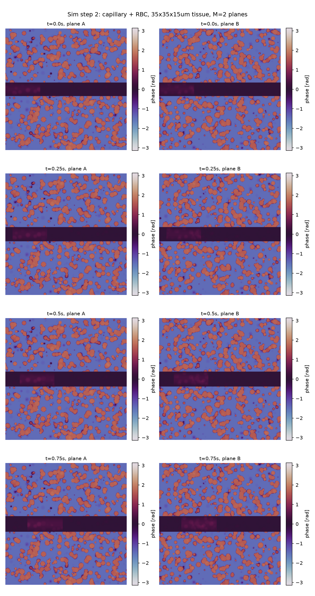
Figure: phase of aberration planes A, B across the 4 timesteps -- the capillary appears as a horizontal band (Y-axis oriented tube, localized in X, spanning the image in Y), and the RBC is visible as a distinct patch moving left to right (into the tissue) within it.

4.2 Two RBCs, gradual entry/exit
A more elaborate scenario: the capillary starts genuinely empty at t=0. RBC 1 gradually enters (its leading edge starts at the tissue boundary and advances -- only part of the cell is visible while crossing the boundary, growing to full length once fully inside, symmetrically shrinking on exit). RBC 2 begins entering once RBC 1's leading edge reaches the tissue's Y-midpoint ("halfway through", spatially -- not a fixed elapsed time, since speed varies with the capillary's dilation). Both cells share one capillary; recording continues at 0.25s steps until both have fully exited -- this produced 17 timesteps (t=0 to 4.0s), computed, not fixed in advance.
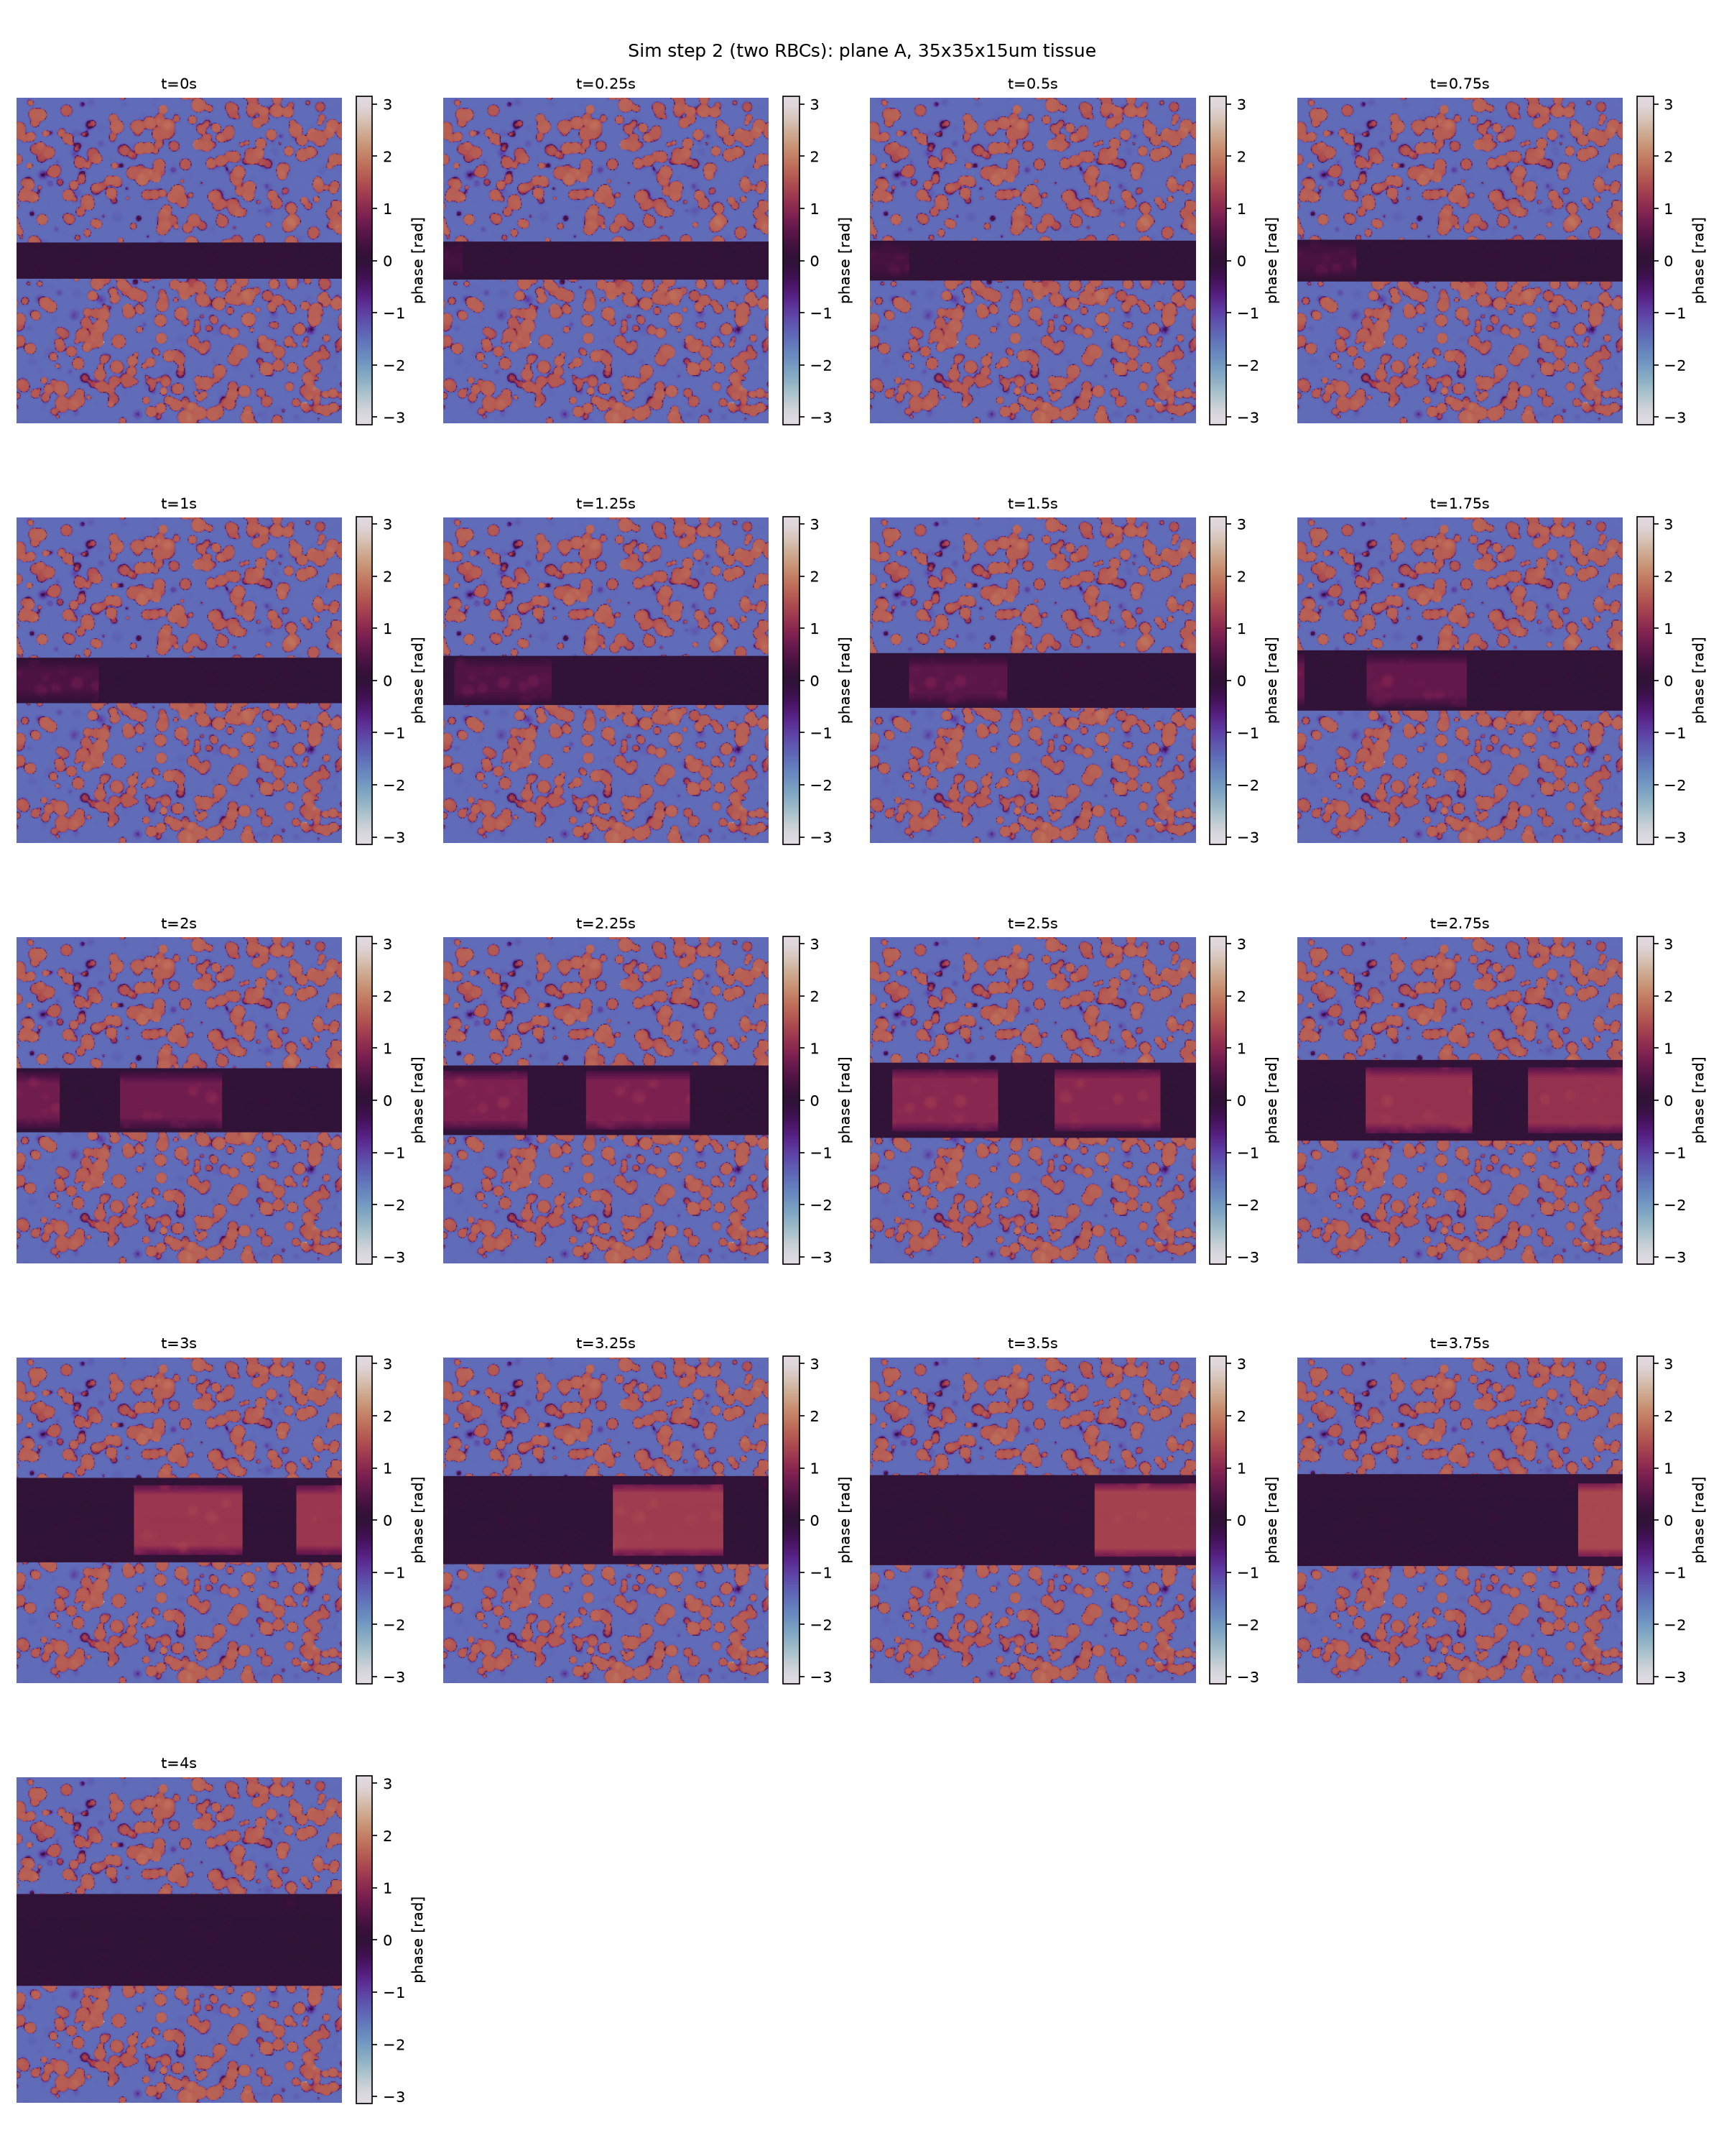
Figure: aberration plane A's phase across all 17 timesteps. RBC 1 grows in from the left starting at t=0; RBC 2 appears (also growing in) starting around t=2s, right on schedule for when RBC 1's leading edge crosses the midpoint; RBC 1 shrinks out around t=3-3.5s; RBC 2 shrinks out by t=4.0s, leaving the band empty again at the final frame.

5. Sim step 3: a correction that goes stale
Step 1's correction assumed perfect, continuously-updated knowledge of the aberration. Step 3 asks a more realistic question: what if the correction planes are calibrated ONCE (from the t=0 snapshot, empty capillary) and then applied UNCHANGED as blood actually flows through the two-RBC tissue from step 4.2? A~=conj(A(0)), B~=conj(B(0)) are fixed; the forward aberration at each timestep, A(t) and B(t), is the timestep's ACTUAL state:
u_out(t) = P(-eps)@A~ @ P(-eps)@B~ @ B(t) @ P(eps)@A(t) @ P(eps) @ u_in
A second pipeline (uncorrected baseline) propagates through the same A(t), B(t) but backpropagates 2*eps in one step with no correction planes applied at all, for comparison.
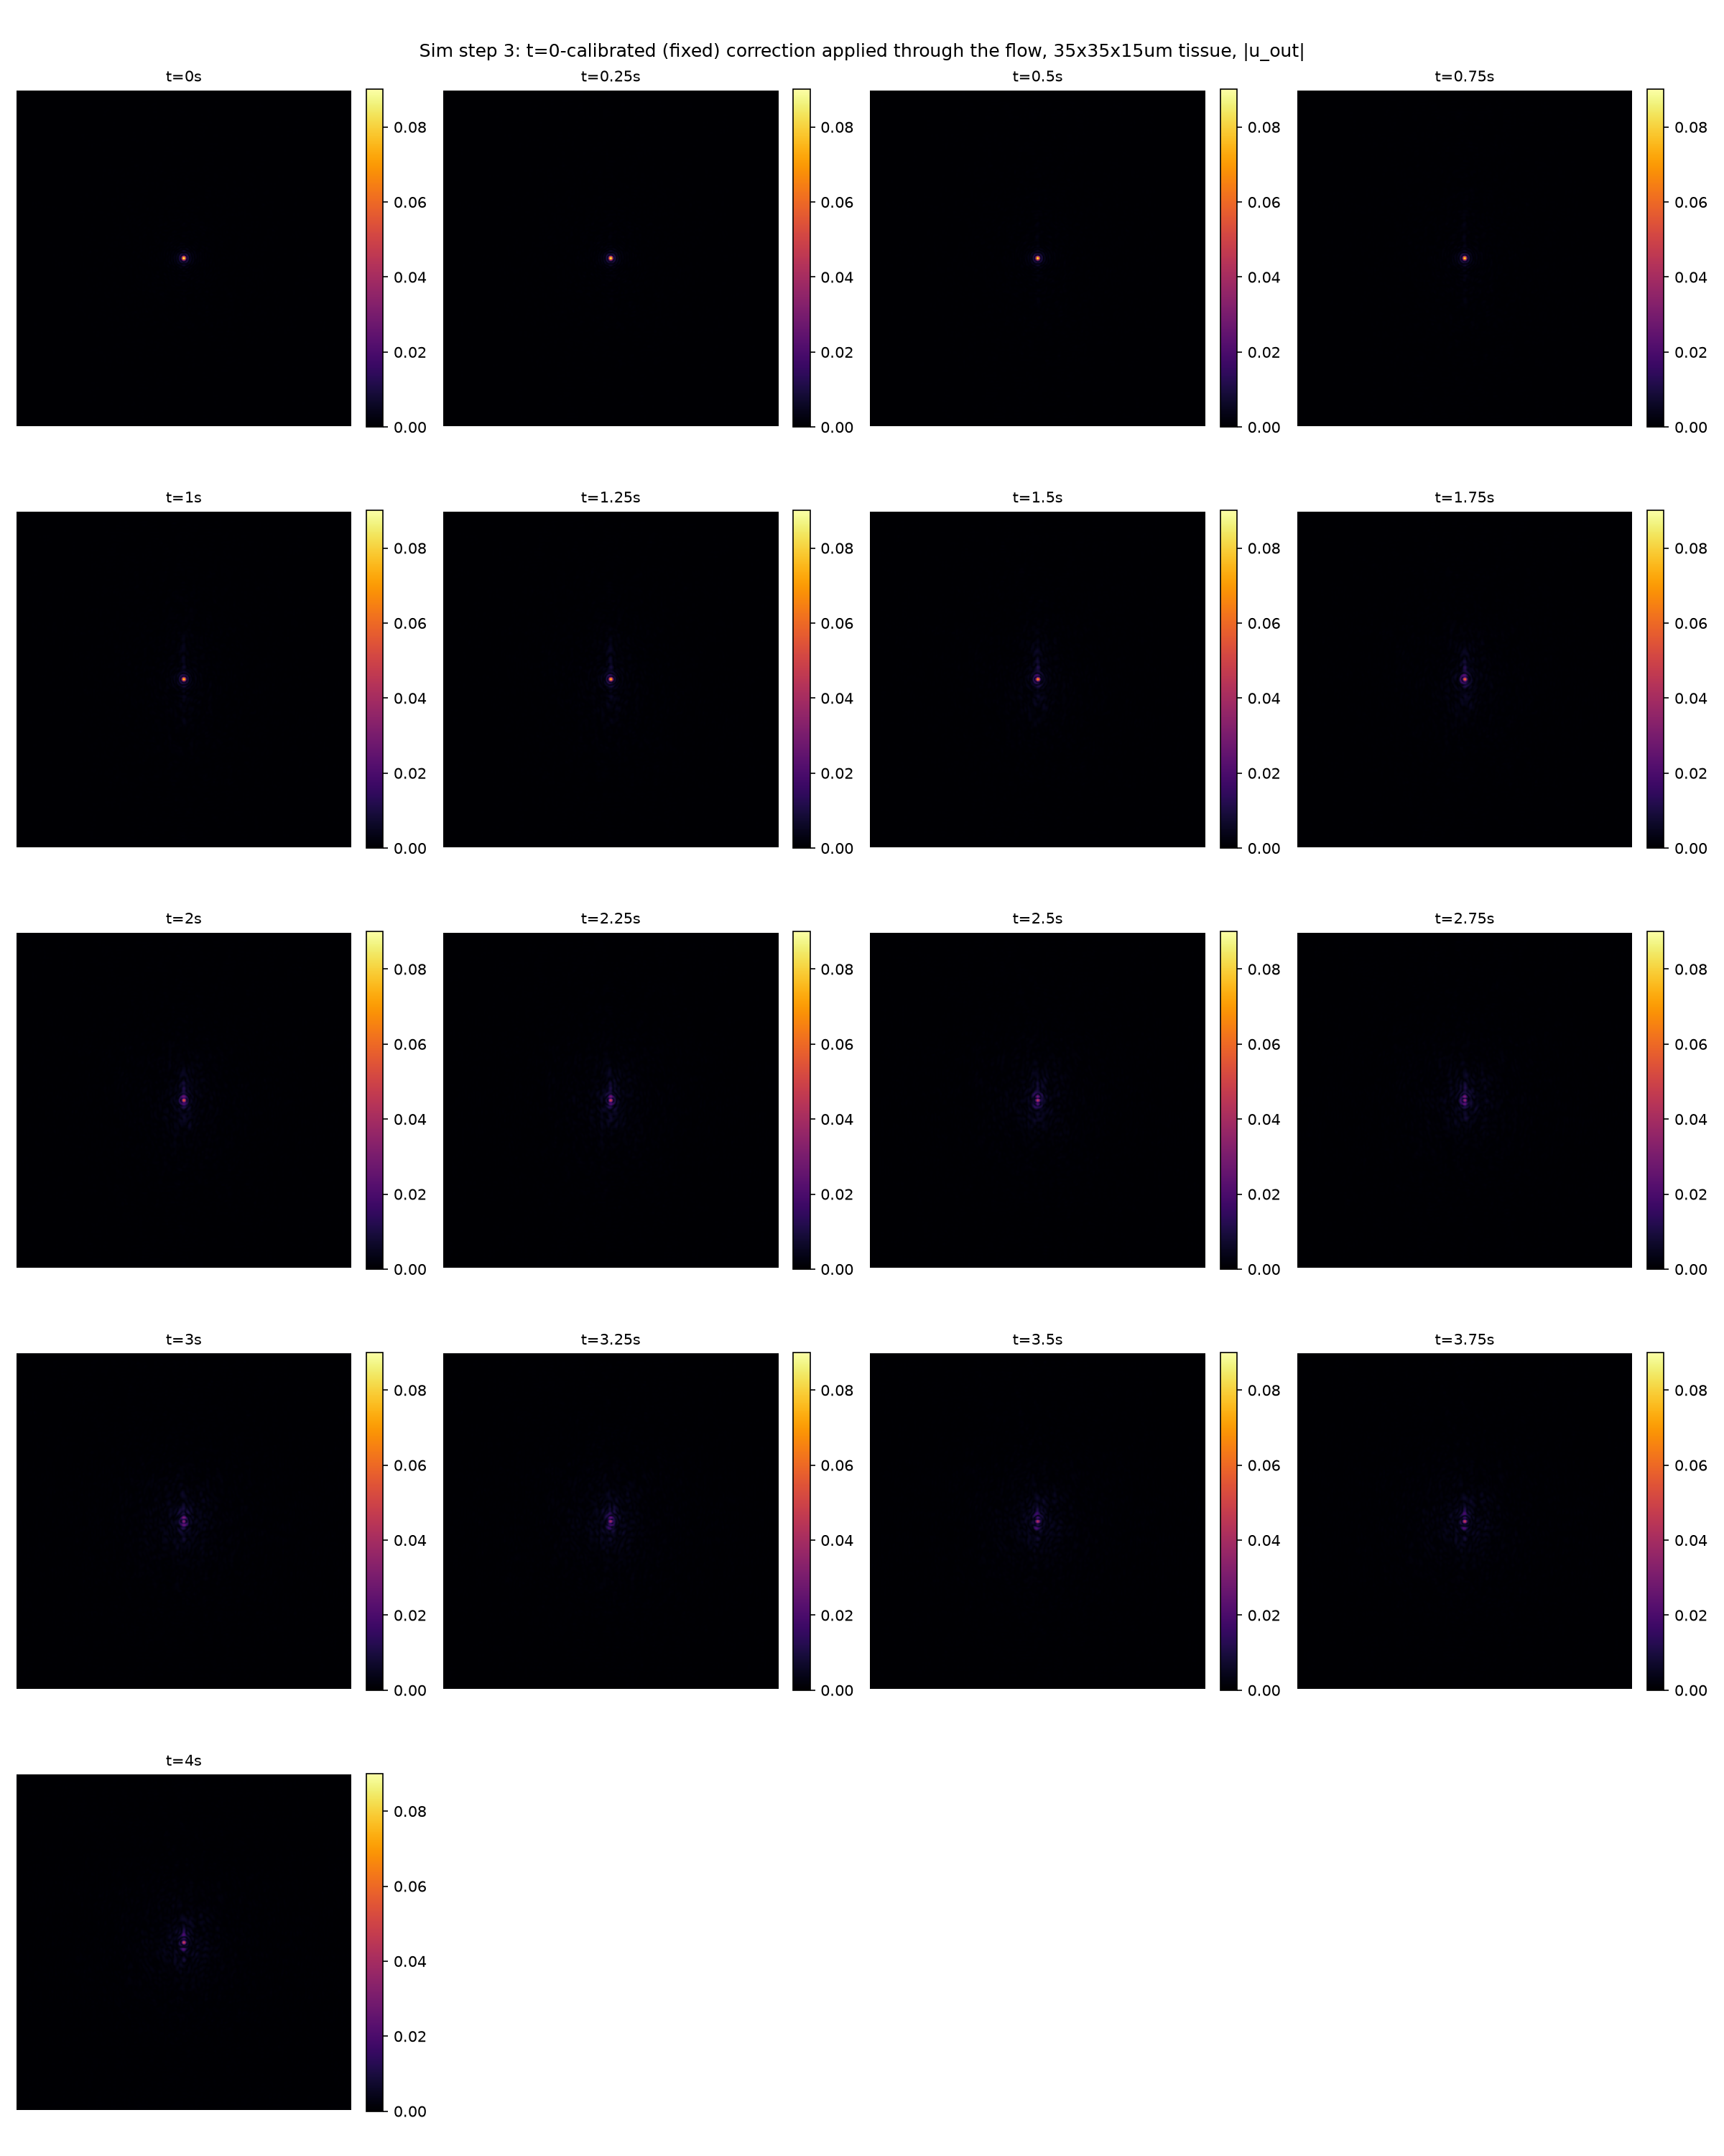
Figure: |u_out(t)| for all 17 timesteps, corrected path, one shared color scale (referenced to t=0's own peak -- the best-case result, since the fixed correction is exact only there). t=0 is a clean, tight, diffraction-limited spot; as RBCs actually flow through (t=1s onward), a residual streak grows where the stale correction can no longer cancel them, most pronounced around t=2-2.75s when both cells are simultaneously present.

6. Speckle correlation statistics: g2(tau)
Per course_material/"8. Laser speckle contrast imaging and multiple scattering theory2.pdf": the field autocorrelation g1(tau)=<E(0)E*(tau)>/<|E(0)|^2> and, via the Siegert relation, G2(tau)=<I(0)I(tau)>=<I>^2+beta*|G1(tau)|^2. We compute the intensity autocorrelation g2(tau) directly for the corrected output series u_out(t), using a SPATIAL average (not a temporal average over multiple (t,t+tau) start-time pairs):
g2(tau) = <I(0)*I(tau)> / <I(0)^2>, I(t) = |u_out(t)|^2
where <...> is the mean over all pixels of the element-wise product, referenced to the t=0 frame. A field correlation g1 was deliberately not attempted this way: spatially averaging the complex field E(0)[x,y]*E*(tau)[x,y] over many independent speckle grains (each with essentially uncorrelated absolute phase) mostly cancels out and isn't physically meaningful without a common phase reference across the image -- exactly why real camera-based speckle imaging works with intensity, not field, statistics (a camera only ever records |E|^2).
A normalization bug was found and fixed during this analysis: the denominator must be the numerator's OWN value at tau=0, i.e. <I(0)*I(0)>=<I(0)^2> (mean of I0 squared) -- not <I(0)>^2 (mean of I0, then squared). The two coincide only for a spatially uniform I(0); for our highly-peaked corrected field they differed by a factor of several thousand. With the fix, g2(0)=1 exactly, by construction (numerator and denominator are the same expression at tau=0), matching the equivalent identity g1(0)=1.
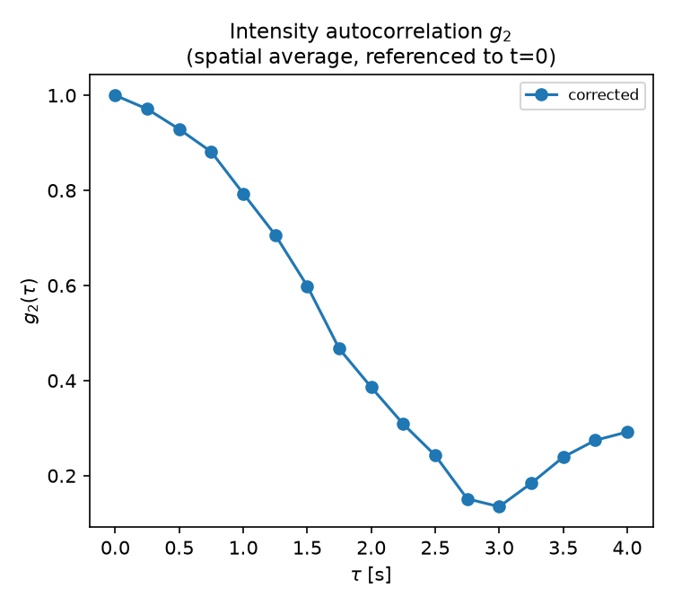
Figure: g2(tau) for the corrected path (uncorrected path intentionally left out of this plot for now).

Why g2 decreases, then increases again
g2(tau) decays from 1.0 (t=0) down to a minimum around tau~2.75-3s, then rises back up to ~0.29 by tau=4.0s. The reason for the increase in correlation is that the RBCs leave the FOV (field of view): by t=4.0s, both red blood cells have fully exited the capillary -- the tissue returns to a state much closer to its (RBC-free) t=0 configuration, so u_out(tau) partially re-correlates with u_out(0). The minimum around tau~2.75-3s corresponds to when the RBC presence (and thus the aberration mismatch against the fixed, t=0-calibrated correction) is greatest.
Note that g2(tau) is not mathematically bounded by 1 for tau>0 -- only g2(0)=1 is guaranteed, since the normalization is anchored solely to the t=0 frame rather than symmetrically to both frames. By Cauchy-Schwarz, g2(tau) <= sqrt(<I(tau)^2>/<I(0)^2>), a bound that can exceed 1 whenever frame tau has more spatial contrast than the reference frame -- this was confirmed numerically to hold at every recorded timestep.

7. Submission folder
submission/main.py is a copy of the final step-3 analysis script; submission/functions.py consolidates every function/constant it imports, directly or transitively, from the full project's step_one.py, step_two.py and step_two_two_rbcs.py modules -- so this folder is self-contained (two files) without needing the full project's module structure.
The generated tissue data (capillary_system/tissue_background_35x35x15_two_rbcs.mat -- the aberration/correction plane data, ~500MB) is NOT included in this submission.
To actually run main.py, that file needs to be regenerated (via the project's MATLAB pipeline: tissue_3d_generator.m, called from capillary_system/run_tissue_3d_generator_capillary_35x35x15_two_rbcs.m) and placed at submission/capillary_system/tissue_background_35x35x15_two_rbcs.mat. submission/main.py was verified to import cleanly and fail ONLY on the missing data file (FileNotFoundError at the load_background call), confirming the code itself -- imports, function wiring -- is correct and complete.

8. Corrected output, cropped for clarity
The full-frame |u_out(t)| figure in section 5 makes the refocused spot hard to see against the 351x351 pixel field (the spot occupies only a handful of pixels near the center). Below is the same data, same shared color scale, cropped to a 50x50 PIXEL window (5x5um, at x_stp=0.1um/pixel) centered on the frame -- the diffraction rings around the spot, and the residual streak that grows as the stale correction fails to cancel the flowing RBCs, are both much easier to see at this scale.
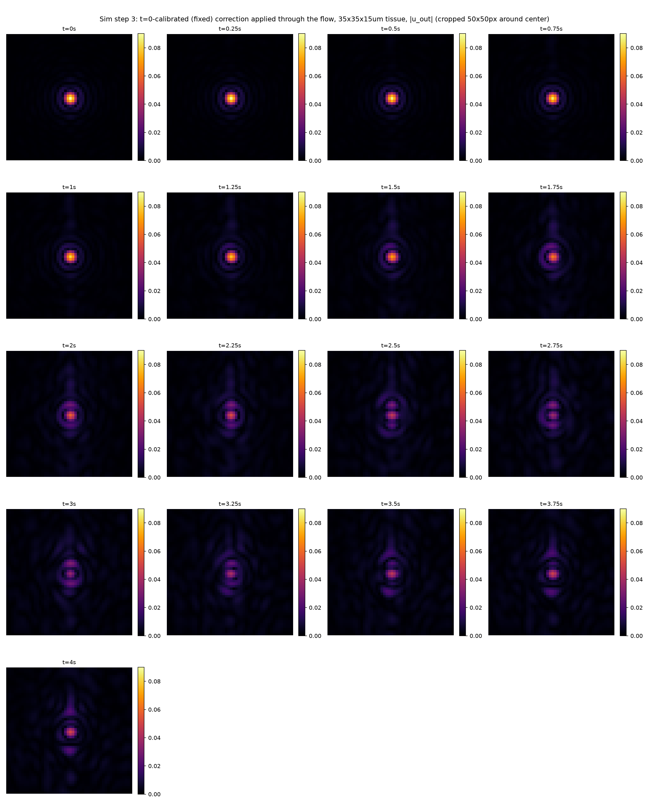
Figure: |u_out(t)| for all 17 timesteps, corrected path, cropped to a 50x50 pixel window around the center (same data and color scale as the section 5 figure).

9. Both aberration planes at three snapshots
Phase of both M=2 aberration planes (A -- nearest the tissue entrance, and B -- at the exit face) at three specific timesteps -- t=0, 1, 2.5s -- for the two-RBC scenario, computed via the same compute_planes_at main.py's own pipeline uses. Top row is plane A, bottom row is plane B, same timestamps in both rows.
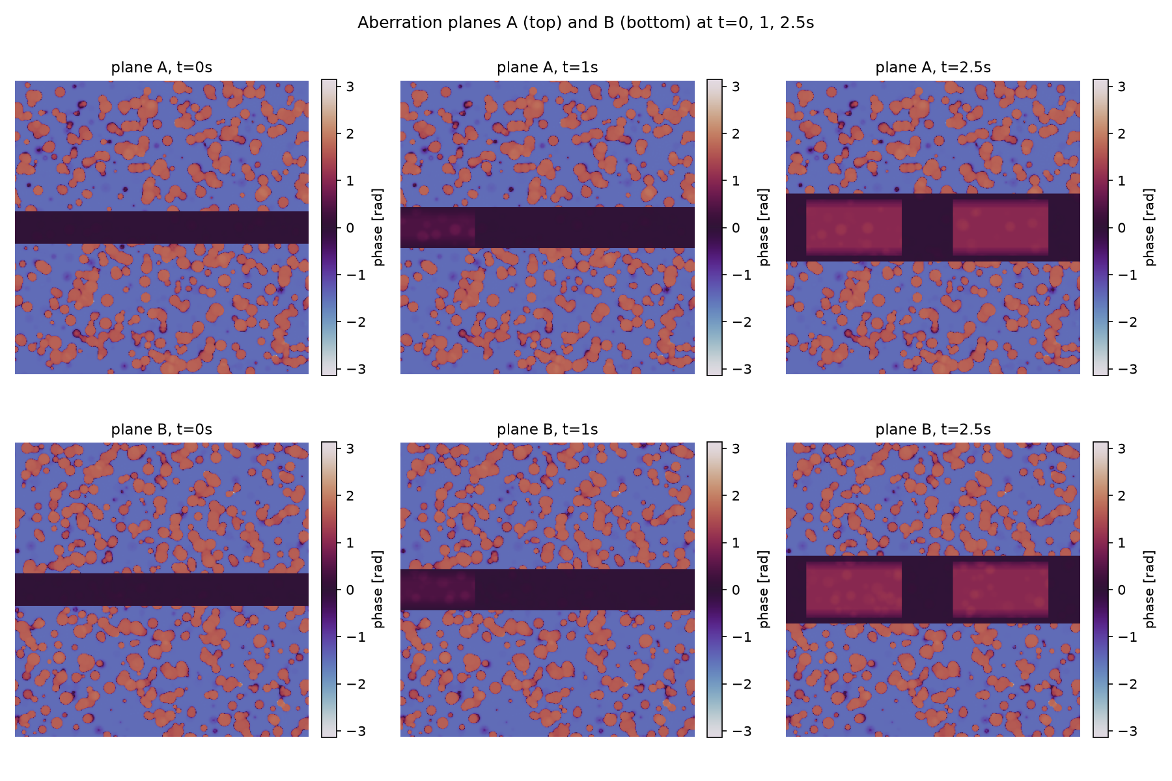
Figure: at t=0 the capillary band is empty in both planes; by t=1s cell 1 has grown in from the left edge (gradual entry) in both; by t=2.5s both cells are simultaneously present in both planes (cell 2 entered around t=1.7s, once cell 1's leading edge crossed the tissue midpoint). The capillary/cell geometry is identical between planes A and B (both share the same capillary), while the surrounding background speckle differs between rows, since each plane averages a different half of the tissue depth.

10. Output Speckle G2(tau)
After the corrected and uncorrected outputs are each brought back to the same plane as u_in (the corrected path's two -epsilon backpropagations, and the uncorrected path's single -2*epsilon backpropagation, both cancel the +2*epsilon forward pass through the tissue), both are propagated one step further: FORWARD by another 2*epsilon of free space (no aberration/correction planes -- plain angular-spectrum propagation). This tests how each speckle pattern decorrelates once it is allowed to leave that refocus/backpropagation plane.
Hypothesis going in: the corrected path's tight, near-diffraction-limited focus is more sensitive to the residual mismatch between the fixed t=0 correction and the actual, flowing tissue, so it should decorrelate FASTER than the already-diffuse uncorrected path.
Result: the opposite. Both curves decorrelate at a similar overall rate (g2 drops from 1.00 at tau=0 to roughly 0.75-0.81 by tau=4.0s), but the corrected path stays consistently ABOVE the uncorrected one at every tau>0, i.e. the uncorrected path decorrelates slightly faster. A plausible reading: 2*epsilon past the refocus plane, the correlation is dominated by how much the tissue itself changed between t=0 and t=tau, not by the corrected path's smaller spot size -- the correction still removes the same t=0 aberration component common to both frames, which if anything makes the corrected pair's overlap slightly more robust than the raw, uncorrected diffuse pattern.
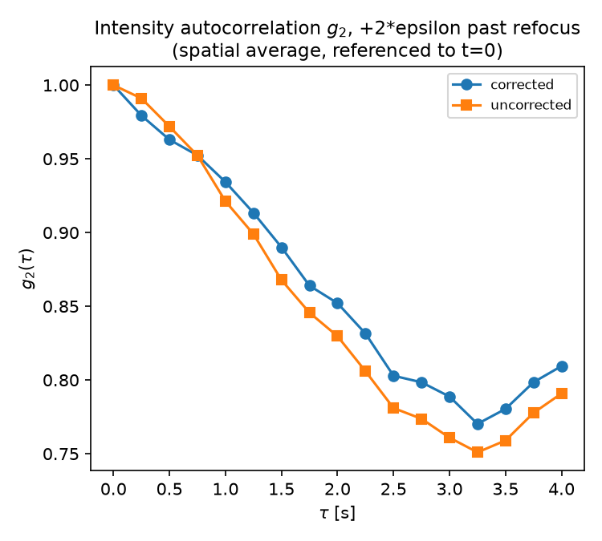
Figure: g2(tau), spatially averaged and referenced to t=0, computed on the further-propagated field for both paths (same g2 definition used throughout section 6). Axes and legend as generated by main.py.

